Smart Implant to Detect Fracture Healing

December 2017

PI: Meir Marmor, MD
(415)206-8378
Meir.Marmor@ucsf.edu

Co-PI’s: Chelsea Bahney, PhD Safa Herfat, PhD Michel Maharbiz, PhD
Chelsea.Bahney@ucsf.edu Safa.Herfat@ucsf.edu maharbiz@eecs.berkeley.edu

CDMI trainee: Monica Lin, BS
monica.lin@berkeley.edu

Report also includes contributions by—
Daniel Grubb, Riley Knox

Contents

Key Findings and Recommendations for Future Studies 3
Motivation: Need and Industrial Relevance 4
Background 4
Aims 6
Methods 6
Results and Discussion 7
Conclusions 12
Timeline 12
Recommendations for Future Studies 12
References 13
List of Presentations and Publications 14
Intellectual Property 14
Appendix 14

Key Findings and Recommendations for Future Studies

We have previously validated that impedance can be used to track the progression of fracture healing in a mouse model, and here aim to develop a fully integrated sensor that can collect and transfer impedance data wirelessly in a larger preclinical model (i.e. rabbit). We conducted extensive calibration to ensure high accuracy of impedance measurements using an Analog Devices AD5933 impedance chip, and paired this with a TI CC1310 microcontroller that has built-in wireless capability. We then showed that measurements can be reliably transferred wirelessly through a human hand. Future studies will focus on collecting data using our sensor in a larger rabbit tibia fracture model, and aim to accurately monitor the state of a fracture over the course of healing.

Motivation: Need and Industrial Relevance

An estimated 15 million fracture injuries occur each year in the United States alone, with up to 20% of patients experiencing some degree of impaired healing [1, 2]. Within this fracture population, 10% will fail to heal appropriately and result in delayed or nonunion, and incidence of nonunion rises to 46% when the fractures occur in conjunction with vascular injury [3]. The risk of nonunion is greater for certain patient populations such as smokers and diabetics, and open fractures of the tibia are especially susceptible [4]. Treatment of fractures costs the U.S. healthcare system $45 billion per year. In particular, multiple reoperations are often necessary to treat nonunions, and 51% of fracture patients do not return to work in 6 months. [2]. This causes substantial disability to patients and represents a significant burden on the healthcare system.

Current Methods of Monitoring

Determining when a fracture is healed is crucial to making correct clinical decisions for patients, but there are currently no standardized methods of assessing fracture union. This is especially important for early diagnosis and treatment of non-unions. A survey of over 400 orthopaedic surgeons revealed that there is a lack of consensus in defining both clinical and radiographic criteria for delayed union and nonunion in tibial fractures. Current available tools for assessing fracture healing most commonly include radiographic methods and clinical evaluation. [4] Plain X-ray radiographs are the gold standard for evaluating fractures, however studies have shown that these correlate poorly with bone strength, do not define union with enough accuracy, and are unreliable for determining the stage of fracture healing. X-ray computed tomography (CT), especially quantitative computed tomography (qCT), has great accuracy in determining bone mineral density (BMD), however the cost and high radiation doses required of CT preclude it from being utilized clinically. Dual energy X-ray absorptiometry (DEXA) is often used to diagnosis osteoporosis due to its ability to measure BMD, but it has decreased accuracy when imaging fractures treated with implants so it is not widely used clinically. [5] Ultrasound is less expensive and does not require exposure to ionizing radiation. In addition, there is evidence that it can detect callus formation before radiographic changes are evident. However, interpretation of findings are highly dependent on operator expertise and thick layers of soft tissue can obscure view of bones. [6] In the clinical setting, physical examination by a physician is still the most relied upon technique to determine fracture union. Patients are examined for local signs of infection, ability to weight-bear, and extent of pain. However, relying on patient-reported questionnaires is very qualitative, and physician assessment is subjective and depends on experience. [4] There exists a need for a quantitative, reliable method to monitor fracture healing and particularly to distinguish between the early stages of healing.

Background

Fracture Healing

Fracture healing progresses via two pathways: intramembranous ossification and endochondral ossification. Intramembranous ossification features healing through direct osteogenesis, where mesenchymal cells directly differentiate into bone-forming osteoblasts. Endochondral ossification is a biphasic process involving chondrogenesis followed by osteogenesis. It occurs through four overlapping phases of repair, beginning with an inflammatory phase, followed by formation of an early callus that matures into a hard callus, and finally remodeling into healthy bone. The inflammatory phase begins with hematoma in response to the trauma, and inflammatory cells debride the wound while skeletal progenitor cells are recruited. As the progenitor cells differentiate into chondrocytes, the fracture enters the soft callus phase which is primarily made up of cartilage. The soft callus becomes a hard callus in the third stage as the matrix is vascularized and cancellous bone replaces the callus. In the final phase, the cancellous bone undergoes remodeling via organized osteoblast and osteoclast activity to form cortical bone. [1, 7, 8]

Clinically, fractures heal primarily through endochondral ossification, although intramembranous ossification occurs simultaneously to various degrees. For example, both processes may be occurring but in different spatial locations. Areas close to the bone ends sometimes heal through intramembranous ossification, while the center of the fracture site will first pass through a cartilage phase. The molecular mechanism for fracture repair is also heavily dependent on stability at the fracture site. Well stabilized fractures will tend to heal by direct osteogenesis, whereas micro-motion of the bone fragments will induce healing through the development of a callus. [1]

During fracture repair there are clearly defined stages of healing that can be well characterized histologically, but are not detectable by standard radiographic techniques.

Electrical Impedance Spectroscopy

Electrical impedance spectroscopy (EIS) measures the dielectric properties of tissue as a function of frequency. It has been used for decades to characterize biological tissues [9-12], with some studies being done specifically on bone [13, 14]. In addition, a small body of literature exists where impedance spectroscopy has been used to monitor fracture healing and has tracked differences in impedance over healing time between fracture groups and control groups [15-18]. While this data is promising, these studies are limited to fractures treated via external fixation, using long pins as electrodes. This may constrain the dynamic range of the signal, and simple two point measurements result in low spatial resolution. More work needs to be done to optimize impedance spectroscopy for use in the fracture environment and to expand its utility to study healing.

Previous Work

We have been collaborating with an Electrical Engineering group at UC Berkeley that has developed an impedance measurement system to study skin health [19], and we are now applying this technique to study fracture healing. The system consists of electrodes to contact the tissue of interest, which are routed to control hardware that interfaces with an LCR meter and laptop, allowing for automatic collection of impedance measurements across a range of frequencies. Our previous work has used a Keysight Technologies E4980AL-100 Precision LCR meter with a 1 V voltage sine wave output signal at frequencies of 20 Hz to 1 MHz to measure impedance magnitude and phase. In our first two years funded by the CDMI, we have shown proof-of-concept results using ex vivo cadaver and mouse fracture callus tissues, as well as conducted pilot in vivo studies in mice to show that impedance can be used to track the progression of fracture healing [20-22].

Aims

Aim 1 – Develop sensor electronics that integrate impedance measurements and wireless capability

1a) Replace the LCR meter with an impedance measurement chip solution
We will first replace the LCR meter with the Analog Devices AD5933 chip. This can be tuned to our application and integrated with a microcontroller to enable us to take impedance measurements in an implant without the need for bulky equipment.

1b) Establish wireless communication, data transfer, and power transfer
To produce a fully implantable sensor, we will utilize Bluetooth or RF (radio frequency) technology to establish wireless communication and data transfer capability. To do this, we will incorporate components necessary to power the appropriate microcontroller and wireless transmitter.

Aim 2 – Prototype sensor for a larger animal model

2a) Use cadaveric tibias to model size restrictions and determine necessary dimensions
In preparation for a future larger animal study, we will use cadaveric rabbit tibias to understand the size constraints for our sensor and build a prototype to scale. Rabbits are larger in size than rodents and have similar tibia load-bearing as humans.

2b) Verify ability to collect data wirelessly through tissue
In an ex vivo rabbit model, we can determine the optimal placement of the electrodes and the measurement technology within the surgical site. We will also verify the sensor’s ability to collect and transmit data wirelessly through soft tissue.

Methods

Aim 1a) Replace the LCR meter with an impedance measurement chip solution
The Analog Devices AD5933 chip has a programmable output voltage to a maximum frequency of 100 kHz, and can be set through a serial I²C interface. The basic impedance measurement range covers 1 kΩ to 10 MΩ, but we can add capability of measuring from 100 Ω to 1 kΩ with additional circuitry. Extensive calibration was necessary to insure accuracy relative to a benchtop LCR meter. This impedance chip was then integrated with a TI CC1310 wireless microcontroller to regulate at which frequencies impedance measurements should be taken and allow for measurements across multiple pairs of electrodes.

Aim 1b) Establish wireless communication, data transfer and power transfer
We selected a microcontroller with built-in wireless capability, which will use a transmitter on the implanted sensor to send the data using sub-GHz frequencies through soft tissue to an external receiver connected to a laptop. Post-processing and analysis can be done off-chip on a laptop.

Aim 2a) Use cadaveric tibias to model size restrictions and determine necessary dimensions
We obtained cadaveric rabbit tibia specimens from UCSF veterinary staff. Using the boards developed in Aim 1, we will determine the maximum size of our sensor and the ideal way to integrate it into a tibia fixation model. We explored multiple options, including designing the sensor in the form of a small bone screw that can be inserted through one of the center holes in a typical bone plate, and integrating the sensing electrodes around an intramedullary nail. We obtained Synthes 247.347 plates that can be used to stabilize rabbit tibia fractures.

Aim 2b) Verify ability to collect data wirelessly through tissue
With the information garnered from Aim 2a, we will design and build prototypes for a rabbit model. This will involve electrodes that sit in the fracture gap, and a small piece of hardware responsible for taking impedance readings and wirelessly transmitting the data that will likely be affixed to an implant. We will mimic this clinical situation by performing analogous surgery on a cadaveric rabbit tibia, and verify our system by testing that it can transmit tissue wirelessly through a human hand. We expect that wireless measurements made with this implanted device will match measurements made using a gold standard Agilent E4980A LCR meter using wired connections.

Results and Discussion

Aim 1a) Replace the LCR meter with an impedance measurement chip solution
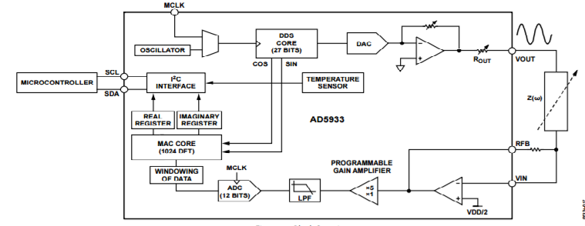
The chip used to replace the LCR meter is the Analog Devices AD5933 chip (block diagram in Figure 1) which can make impedance measurements (magnitude and phase) from 1kΩ to 100kΩ at frequencies ranging from 1kHz to 100kHz. With external circuitry added, the device is also capable of measuring impedances below 1kΩ. However, with this application, the impedances of primary interest range from 1kΩ to several hundred kΩ. For initial development, an Arduino was used to interface with the AD5933 chip over I²C. This required creating an Arduino application to control the chip and retrieve data, as well as several Python scripts to automate calibration and data collection.
Figure 1. Block diagram of AD5933 chip.

The AD5933 chip supplies real and imaginary coefficients from an on chip DFT engine for each frequency that a measurement is taken at. When taking a measurement, there are two important impedances relating to the system setup: the unknown impedance and the feedback resistor, R_{FB}. The unknown impedance is simply the DUT (device under test). R_{FB} is placed between the R_{FB} pin and the measurement V_{in} port of the chip. This resistor must be set properly relative to the unknown impedance to ensure the ADC does not saturate. In other words, the value of R_{FB} will be set by the range of desired impedance. The equation to calculate what the R_{FB} should be based off the minimum impedance you are trying to measure is described in Equation 1:

$R_{FB}=\frac{\left(\frac{V_{DD}}{2} - 0.2\right)×Z_{min}}{\frac{V_{pk-pk}}{2} + \frac{V_{DD}}{2} -{ V}_{DCOffset}}$ [1]

Z_{min} is the minimum impedance, V_{pk-pk} is the peak to peak voltage used by the chip during the measurement, and V_{DCOffset} is the DC offset of that voltage. The AD5933 has 4 choices of peak to peak voltage of the wave sent through the DUT, each of which will require a different R_{FB} value as shown above. We selected the 2V peak to peak option to allow for measurement in a range of approximately 40 times the minimum expected impedance.

After the desired impedance range has been set, a calibration can be run. The calibration resistor should be carefully chosen to be about one third of the maximum desired impedance value to maximize accuracy. The calibration is performed by taking a measurement of a resistor with a known value at every frequency in the desired frequency range. The real and imaginary components are translated into a magnitude and phase angle by $\sqrt{R^{2}+I^{2}}$ and $\tan\left(\frac{I}{R}\right)×\frac{{180}^{°}}{π}$, respectively, where R is the real component and I is the imaginary component. This can then be used to calculate calibration coefficients for each frequency using Equation 2:

$Calibration Coefficient= \frac{1}{Known Magnitude × Measured Magnitude}$ [2]

An unknown impedance can then be taken, with the magnitude and phase angle calculated in the same way and plugged into Equation 3 at each frequency to retrieve the unknown impedance value: $Impedance= \frac{1}{Calibration Coefficient×Measured Magnitude}$ [3]

Calibrating for phase is simpler because the calibration resistor should not add any phase to the signal since it has no reactive component. Therefore, the phase angle measured in the calibration is entirely the phase of the system, and can just be subtracted directly out of the unknown impedance measurement.

Accuracy can be optimized by adjusting the calibration and feedback resistors. The AD5933 chip can take more accurate measurements using a smaller desired impedance range. Plots of impedance magnitude and phase for a 250 kΩ resistor in parallel with a 47 pF capacitor are shown in Figure 2. The measured value closely tracks with the ideal value, and the best fit adjusted value decreases the error further. Calibration was done using a 180 kΩ resistor.

Figure 2. Impedance magnitude (left) and phase angle (right) plotted over frequency for ideal values, measured values, and best fit adjusted values (for |Z| only).

Aim 1b) Establish wireless communication, data transfer and power transfer
We explored several options to implement wireless capability for our system. We have selected the TI CC1310 sub 1-GHz ultra low power wireless microcontroller. The lower frequency is chosen to better transmit through tissue.

Powering the device remotely via an energy harvesting method would be ideal, but we found that our size constraints were too restrictive to implement this reliably. There are 4 main techniques we examined – light, movement, temperature, and radio. Light is not applicable to this project as the sensor is implanted in the body. It is possible to extract a small amount of energy from movement (i.e. vibrations) using piezo materials, but there is little information to quantify how much energy could be harvested and would require an entirely separate study to determine whether the motion of a rabbit would be able to generate enough energy over time. Thermoelectric generation can work pretty well, but requires a temperature gradient (e.g. being placed on a window sill), which is not relevant in the body. Radio would require prohibitively large antennas to fit in a rabbit model, and the live tissue would likely absorb most of the transmitted energy.

In our application, we only need to take measurements for about 10-30 seconds per day. The TI CC1310 microcontroller can be set to a very low power sleep mode, and only occasionally have to transmit data. In addition, most of the data processing can be done externally to the system, so the data storage and transmit requirements are low. In idle mode, the microcontroller requires about 5 uA per hour, resulting in a total of 7 mAh over 8 weeks. Taking measurements at a subset of 8 frequencies (2, 5, 10, 15, 25, 50, 75, and 99 kHz) takes roughly 10 seconds, and translates to a total of approximately 3 mAh over 8 weeks. In total, the device would require 10 mAh, which means the system can easily be run off of 2 AA or AAA batteries, and a Lithium Polymer battery can be selected for a smaller footprint. An example of this system is shown in Figure 3.

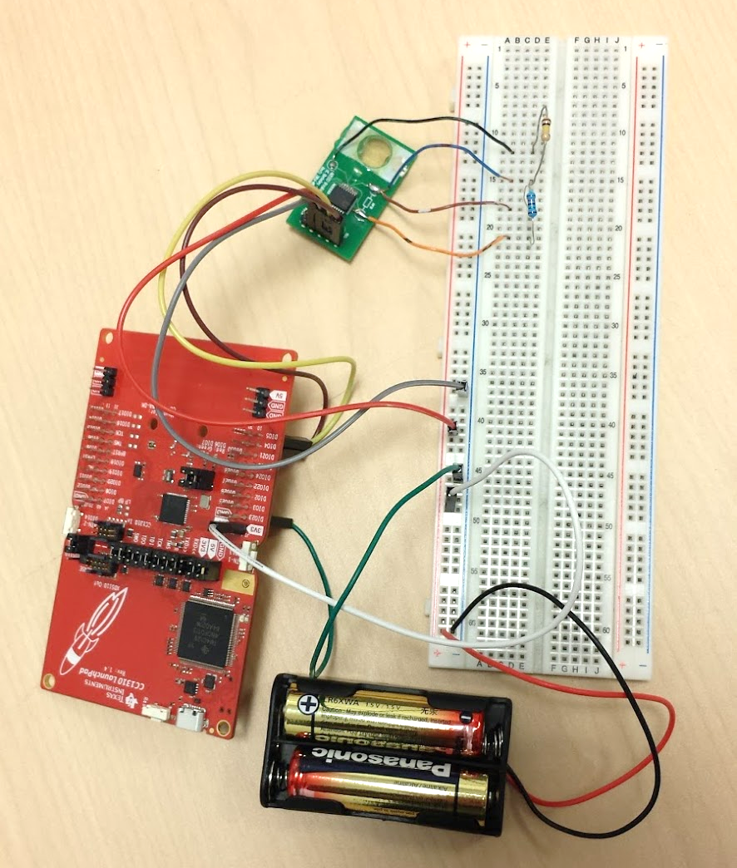
Figure 3. Prototype of wireless sensor that incorporates an impedance chip and wireless microcontroller uses 2 AA batteries to power the system.

Aim 2a) Use cadaveric tibias to model size restrictions and determine necessary dimensions
Mock surgeries were performed on cadaveric rabbit tibia to understand the best surgical approach and determine maximum dimensions of the sensor. Both a medial and lateral approach were tested, as shown in Figure 4, and it was determined that a medial approach was more appropriate for our application. While the lateral approach meant the sensors would be pressed up against muscle tissue and perhaps impedance mobility, the medial approach allows the flexible skin to be stretched carefully over the implant and minimize intrusion.

Figure 4. Cadaveric rabbit tibias stabilized with bone plates using medial (left) and lateral (right) surgical approaches.

We plan to affix the sensor to the bone plate, and used the mock surgeries to determine the maximum allowable dimensions of the sensor:

Bone Plate: 52mm long x 5.5mm wide x 1.5mm thick
Sensor Max Dimensions: 82mm long (extra 10mm past the plate in the inferior direction, extra 20mm past the plate in the superior direction) x 7.5mm wide (up to 10mm wide at the superior end of the bone) x 3.5mm thick
Aim 2b) Verify ability to collect data wirelessly through tissue
Measurements were taken using the AD5933 chip and then wirelessly transmitted to a receiver connected to a laptop. When a hand was placed over the transmitter on the sensor side, the strength of the signal decreased as expected, but data was still able to be reliably transmitted. Since the tissue of the human hand is thicker and denser than rabbit skin, we do not anticipate any issues in moving this to a rabbit model.

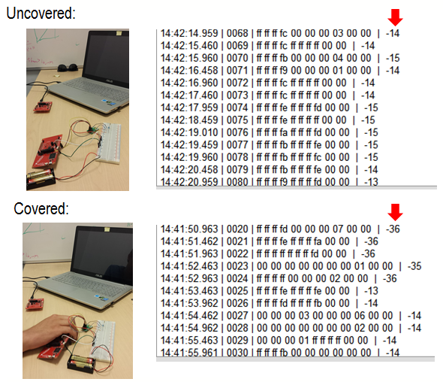
Figure 5. Measurements taken and transmitted wirelessly from an uncovered transmitter (top) and transmitter covered by a human hand (bottom).

We then laid out all the individual chips and associated discrete components, as well as a smaller 3V coin cell battery, onto a polyimide substrate to mimic how these parts could all be integrated onto a single board, shown in Figure 6. This was then encapsulated in a medical-grade epoxy to insulate and protect the electronics. In our prototype, the electrodes can be fed through a hole in the center of the board and bone plate.

Figure 6. Oblique (left), top (middle), and side (right) views of the prototype sensor using individual chips and associated discrete components, as well as a smaller coin cell battery.

Conclusions

We have developed a prototype to wirelessly collect impedance data an AD5933 impedance chip, a TI CC1310 wireless microcontroller, and 3V battery. Data collected using the impedance chip indicates that it is highly accurate relative to a benchtop LCR meter. We have also validated that the data can be transmitted wirelessly from a transmitter on the implanted board to a receiver connected to a laptop through a human hand. Paired with our previous data this demonstrates the utility of impedance to track the progression of fracture healing, we can begin a study in a larger preclinical model and get closer to translating this device to clinical use. Ultimately, we aim to arm physicians with an additional quantitative measure of the state of fracture healing, and thus enable timely intervention to prevent problem fractures from progressing to nonunion.

Timeline

With this grant we have shown that our system works in principle using evaluation boards of the various off-the-shelf components. We are currently completing full integration of the implantable sensor prototype to use for a rabbit model. We plan to conduct this rabbit study in the next year.

Recommendations for Future Studies

We have validated the use of off-the-shelf components to collect impedance measurements in a way that can be translated to a fully implantable sensor, rather than relying on bulky benchtop equipment as we previously did. With the in vivo data collected in a mouse fracture model that was made possible by our previous years of funding from the CDMI grant, we have now been awarded a larger NSF PFI:AIR-TT (Accelerating Innovation Research) to fund an in vivo preclinical rabbit study. This study aims to monitor tibia fracture healing in a larger preclinical model using a fully integrated implantable sensor.

References

- M. L. Schenker, et al., “Fracture Repair and Bone Grafting,” Orthopaedic Knowledge Update, pp. 15-25, 2014.
- American Academy of Orthopaedic Surgeons, “The Burden of Musculoskeletal Diseases in the United States”, Rosemont, IL, 2008.
- K. F. Dickson, et al., “Importance of the blood supply in the healing of tibial fractures,” Contemp Orthop, vol. 30, no. 6, pp. 489-493, 1995.
- S. Morshed, “Current Options for Determining Fracture Union,” Advances in Medicine, pp. 1-12, 2014.
- S. P. Whiley, et al., “Evaluating fracture healing using digital X-ray image analysis,” CME, vol. 29, no. 3, pp. 102-106, 2011.
- V. C. Protopappas, et al., “Ultrasonic Monitoring of Bone Fracture Healing,” Transactions on Ultrasonics, Ferroelectrics, and Frequency Control, vol. 55, no. 6, pp. 1243-1255, 2008.
- B. McKibbin, et al., “The Biology of Fracture Healing in Long Bones,” Journal of Bone and Joint Surgery, pp. 150-162, 1978.
- H. M. Frost, et al., “The Biology of Fracture Healing: An Overview for Clinicians, Part I,” Clinical Orthopaedics and Related Research, pp. 283-293, 1989.
- R. D. Stoy, K. R. Foster, and H. P. Schwan, “Dielectric properties of mammalian tissues from 0.1 to 100 MHz: a summary of recent data,” Phys Med Biol, vol. 27, no. 4, pp. 501-513, 1982.
- H. Jongschaap, et al., “Electrical impedance tomography: a review of current literature,” European Journal of Radiology, vol. 18, pp. 165-174, 1994.
- D. A. Dean, et al., “Electrical Impedance Spectroscopy Study of Biological Tissues,” J Electrostat, vol. 66, no. 3-4, pp. 165-177, 2008.
- S. Gabriel, R. W. Lau, and C. Gabriel, “The dielectric properties of biological tissues: II,” Phys Med Biol, vol. 41, pp. 2251-2269, 1996.
- I. V. Ciuchi, et al., “Impedance spectroscopy characterization of bone tissues,” Journal of Advanced Research in Physics, vol. 1, no. 1, pp. 1-5, 2010.
- S. Schaur, B. Jakoby, and G. Kroureif, “Position-dependent characterization of bone tissue with electrical impedance spectroscopy,” IEEE, pp. 1-4, 2012.
- T. Yoshida, et al., “Assessment of fracture and distraction callus by monitoring bone electrical impedance in rabbits,” 54th Annual Meeting of the Orthopaedic Research Society, 2008.
- T. Hirashima, et al., “Evaluating Bone Union of Distal Radius Fractures by Measuring Impedance Values”, Orthopedics, vol. 32, no. 1, 2009.
- N. Yamada, et al., “Analysis of Increase in Bone Electrical Impedance in Fracture Healing”, 55th Annual Meeting of the Orthopaedic Research Society, 2009.
- T. Yoshida, et al., “Assessment of distraction callus in rabbits by monitoring the electrical impedance of bone”, Acta Orthopaedica, vol. 81, no. 5, pp. 628-633, 2010.
- S. L. Swisher, et al., “Impedance sensing device enables early detection of pressure ulcers in vivo,” Nature Communications, vol. 6, 2015
- M. Lin, et al. “Impedance Spectroscopy to Monitor Fracture Healing.” IEEE Engineering in Medicine and Biology Conference, 2015.
- M. Lin, et al. “New Opportunities for Fracture Healing Detection: Impedance Spectroscopy Measurements Correlate to Tissue Composition in Fractures.” J. Orthop. Res. doi:10.1002/jor.23570, 2017.
- M. Lin, et al. “Using Impedance to Track Fracture Healing Rates in Mice In Vivo: A Pilot Study.” IEEE Engineering in Medicine and Biology Conference, 2017.

List of Presentations and Publications

Presentations
- M.C. Lin. “Impedance Spectroscopy Device Detects Fracture Progression in Mice.” Berkeley-UCSF Annual Bioengineering Conference (Nov. 2016). [talk]
- M.C. Lin, D. Hu, F. Yang, S.T. Herfat, C.S. Bahney, M.M. Maharbiz, M. Marmor. “Using Impedance to Characterize Fracture States in Externally-Stabilized Mouse Tibia Fractures vs. Critical-Sized Defects.” ORS Annual Meeting (Mar. 2017). [poster]
- M.C. Lin. “Beating the Waiting Game: Early Detection of Fracture Nonunion.” ORS Annual Meeting (Mar. 2017). [ISFR Junior Symposium 3-Minute-Thesis Competition – 2nd place]
- M.C. Lin, D. Hu, F. Yang, S.T. Herfat, C.S. Bahney, M.M. Maharbiz, M. Marmor. “Using Impedance to Track Fracture Healing Rates in Mice In Vivo: A Pilot Study.” IEEE Engineering in Medicine and Biology Conference: Jeju Island, South Korea (Jul. 2017). [podium talk]

Publications
- M.C. Lin, F. Yang, S.T. Herfat, C.S. Bahney, M. Meir, M.M. Maharbiz. “New Opportunities for Fracture Healing Detection: Impedance Spectroscopy Measurements Correlate to Tissue Composition in Fractures.” J. Orthop. Res. doi:10.1002/jor.23570 (2017).
- M.C. Lin, D. Hu, F. Yang, S.T. Herfat, C.S. Bahney, M.M. Maharbiz, M. Marmor. “Using Impedance to Track Fracture Healing Rates in Mice In Vivo: A Pilot Study.” IEEE Engineering in Medicine and Biology Conference: Jeju Island, South Korea (Jul. 2017). [conference proceeding]
- M.C. Lin, S.T. Herfat, C.S. Bahney, M. Meir, M.M. Maharbiz. “Implantable Sensor Utilizes Impedance Spectroscopy to Differentiate Between Union and Nonunion models.” [article in preparation]

Intellectual Property

Title(s) of IP Disclosure(s)

Quantitative Tool Using Impedance Spectroscopy to Monitor Fracture Healing – filed with UC Berkeley and UCSF on July 13, 2015.

Patent Title(s), Stage of Submission, and Patent # (if applicable)

Provisional Application (no. 62/205,561) filed August 14, 2015. PCT Application (no. US16/46568) filed August 11, 2016.

Appendix

Data accessible on UCSF Box: https://ucsf.box.com/s/53ecpgcmvaqz68j5y0r3j3ith5b8jrqi
(Contact monica.lin@berkeley.edu with any issues or for more information)

